Clean and Transform data Assignment

Use the following URL to import data into Power BI:
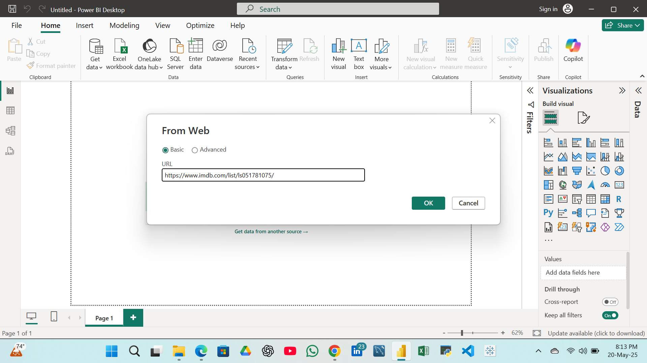
https://www.imdb.com/list/ls051781075/
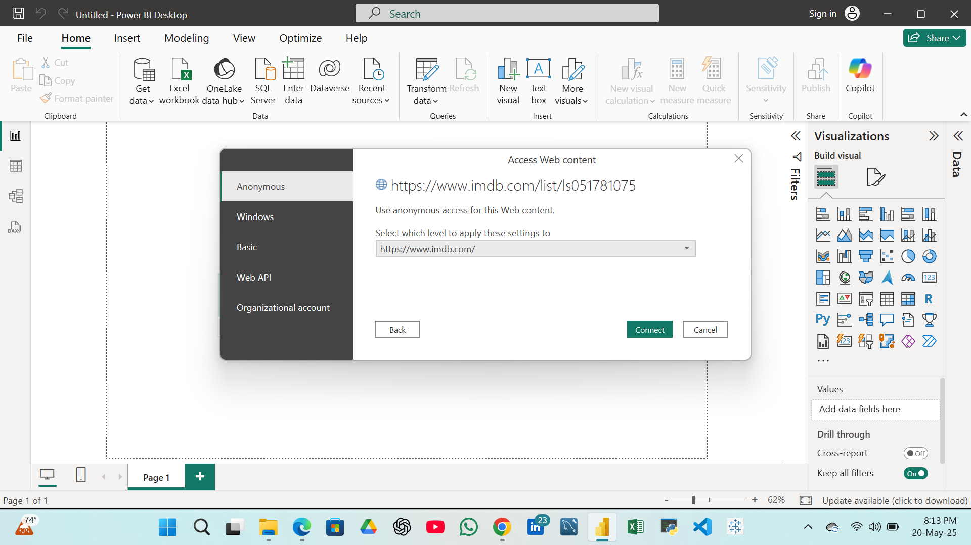
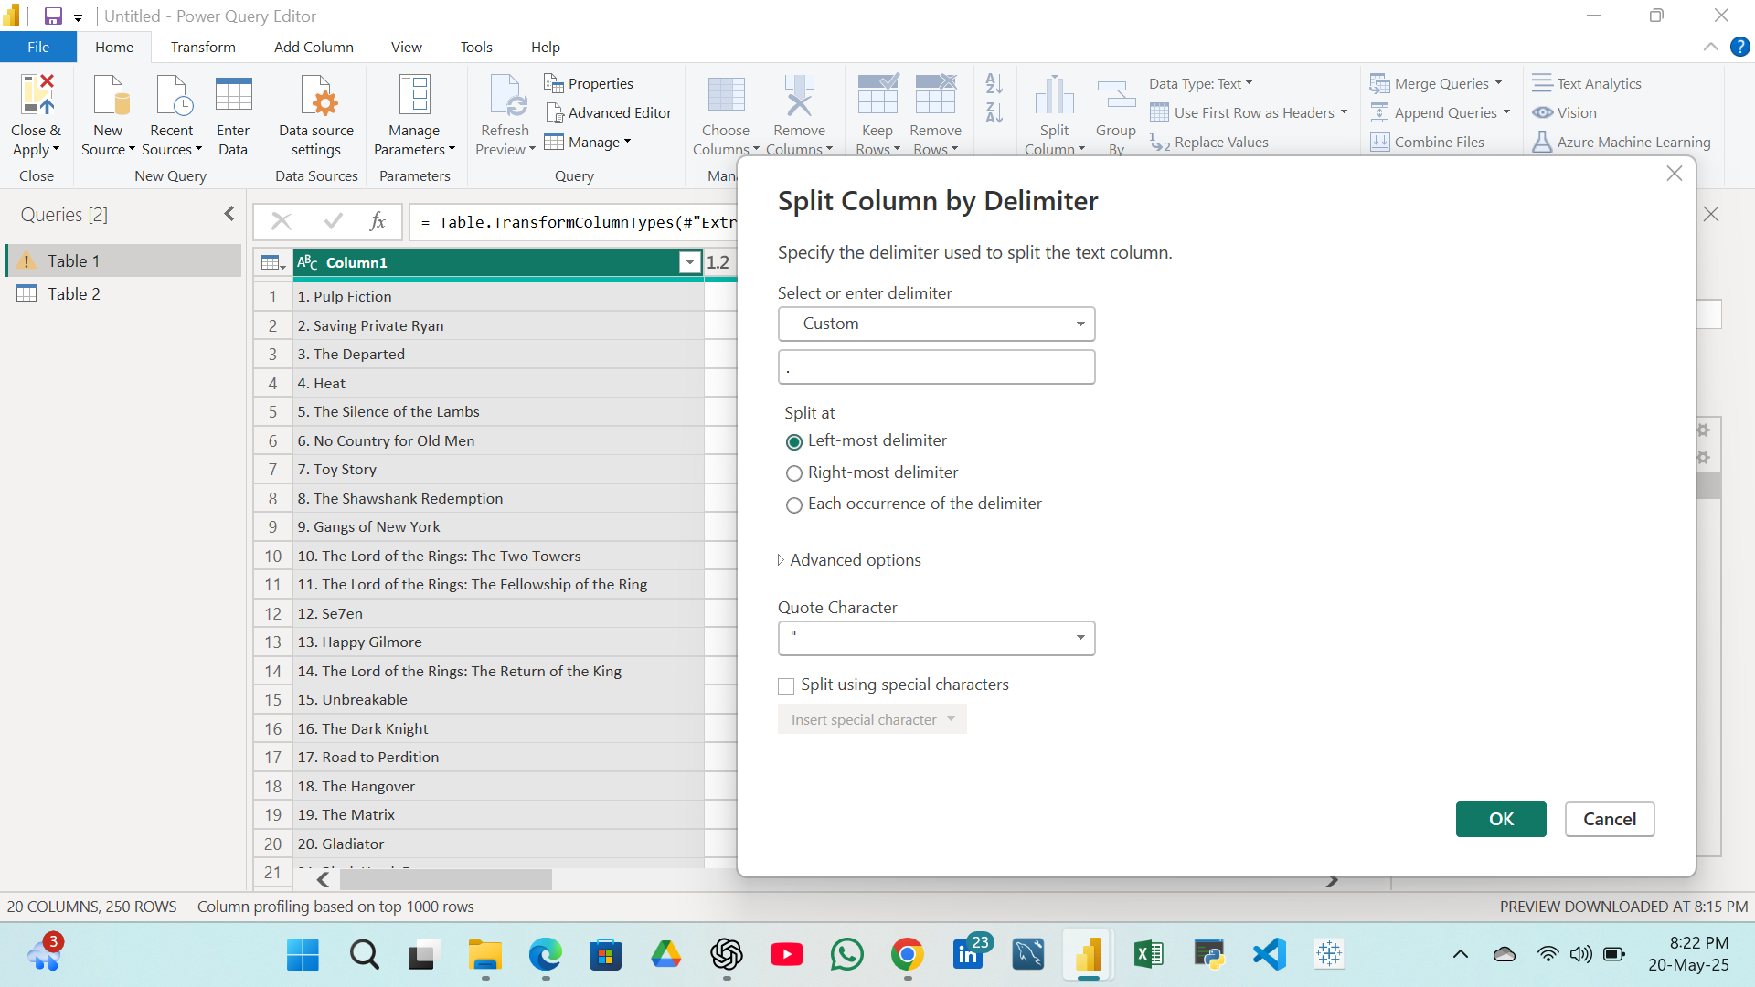
Separate the Number from Movie Titles and Give column name as Sr No. & Title.

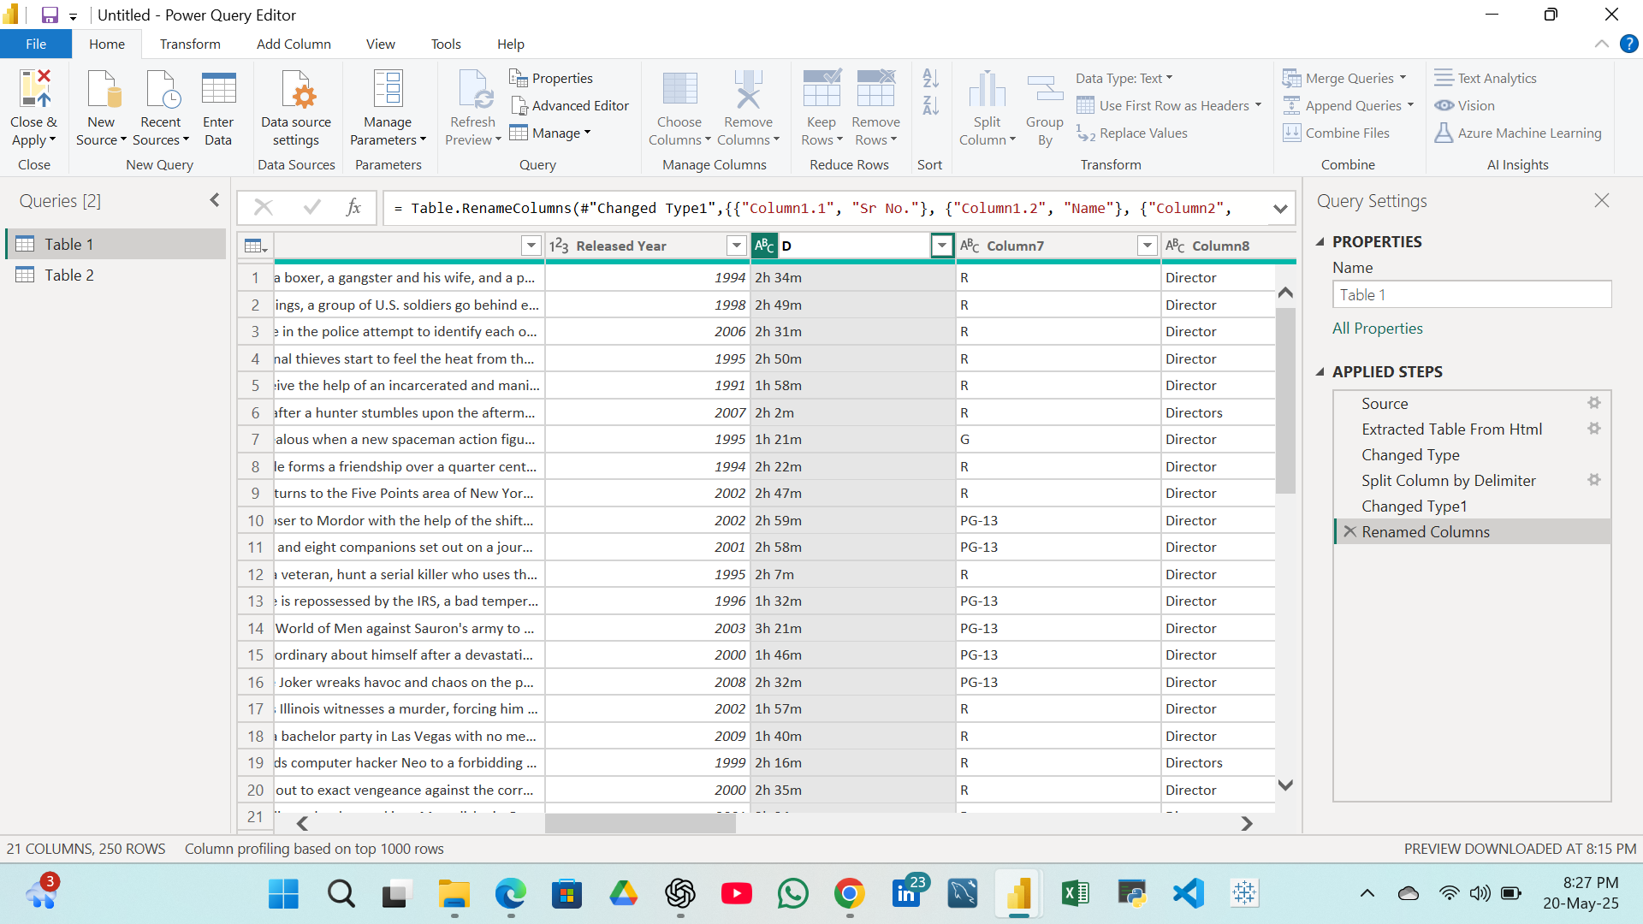
Rename columns 2 as Ratings, column 3 as Views,column 4 as description. Column 5 as Released Year, Column 6 as Duration
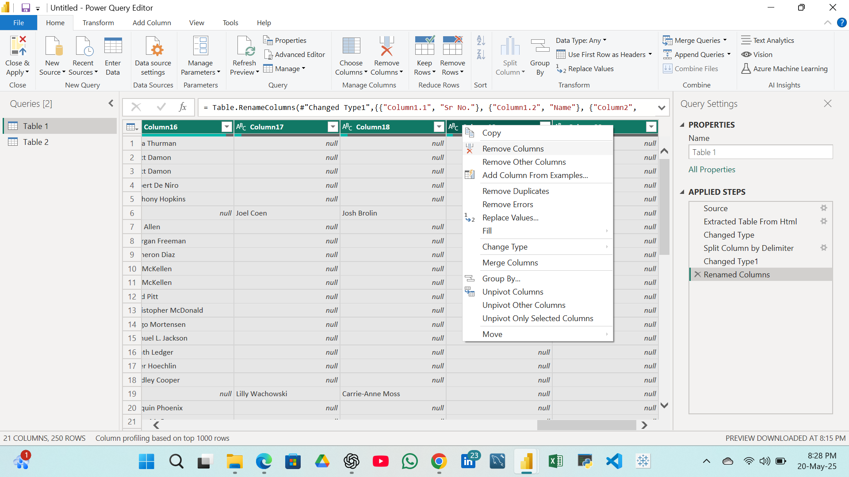
Remove the columns from 7 to 20 as they are unnecessary columns

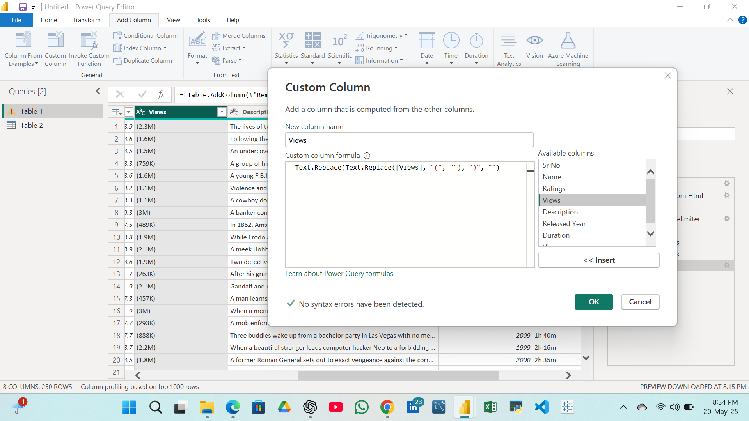
Remove the Brackets () from column 3.

